A Few Thoughts on the Double-Parashah Matot-Mas’ei (Numbers 30:2 - 36:13; Jeremiah 2:4-28; Jeremiah 4:1-2)
July 29, 2022 Cantor Neil Schwartz

With the double Torah Portion of Matot–Mas'ei, the journeys in the Book of Numbers are near their end. During the 38+ years of Sefer BaMidbar, the Israelites have experienced the anger of Moses and of God, resulting from the failed mission of the spies, the rebellion of Korach, and the complaining that has gone on constantly. An entire generation has died out, Miriam and Aaron have died, and the death of Moses has been foretold. Despite this, by the end of Sefer BaMidbar the Israelites are finally becoming a Nation.
Three instances in the combined Torah portions of Matot-Mas'ei bring this coalescence to the fore. First is a request of the tribes of Reuben and Gad to settle in Transjordan where the land is good for their cattle, rather than claim their tribal portions in the Promised Land (Chapter 32). Moses chides them for their apparent selfishness, but they offer a compromise. Reuben and Gad will send "shock-troop" warriors to fight beside the other tribes in the conquest of Canaan, and then will they return to their families and land.
Second, among the rules given in these final chapters, we find provision for cities of refuge. These were where a person who accidentally kills someone would be protected from the vengeance of the family of the deceased (35:9-34). This is the culmination of a general discussion about land-holding which includes the fact that the Levites would be assigned cities, but they would not hold territories. That aversion to Priestly land-holding may have come from Israelite experience in Egypt, where Pharaoh and priests held almost all land, which led to a highly stratified and inherently unjust society.
Finally, we revisit the case of the daughters of Tz'lofchad. Previously, they won the right to inherit land from their father (27:1-11). Here, their marriage prospects are limited, to keep their land-holdings within their tribe (36:1-12). Just as God deemed their original plea to be correct, here God affirms the legitimate concerns of their fellow tribe members. In any case, even with this adjustment, the fact that women could inherit land is something which was not allowed in much of the world until recent times!
To summarize the general subject of which Israelite tribes would be granted which portions of land in Canaan, it is interesting to compare the size and location of their land-holdings with the birth-mothers of Jacob's twelve sons. Larger and more powerful tribes were sons of Leah and Rachel (Ephraim and Menashe were sons of Joseph), and smaller and weaker tribes were descended from Jacob's concubines. This dichotomy may also be at work in "streams of tradition" that comprise the formation of the Torah, reflected in the "Northern " vs. "Southern" versions of similar intertwined stories.
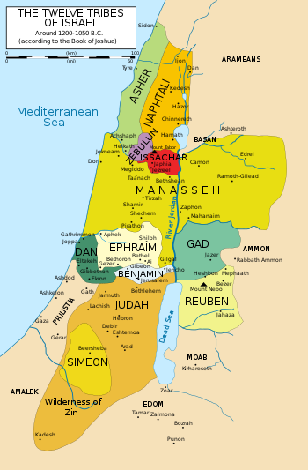
Shabbat Shalom!

